

Tangential Sensitivity of ADL5902-Based Receivers

[002.35.25.05.20-003]

Status: **Draft**

|  |  |  |
| --- | --- | --- |
| **PREPARED BY** | **ORGANIZATION** | **DATE** |
| R. Nguyen | NRAO Electronics Division | 7/28/2023 |

|  |  |  |
| --- | --- | --- |
| **APPROVALS** | **ORGANIZATION** | **SIGNATURES** |
|  |  |  |
|  |  |  |

|  |  |  |
| --- | --- | --- |
| **RELEASED BY** | **ORGANIZATION** | **SIGNATURE** |
|  |  |  |

**Change Record**

|  |  |  |  |  |
| --- | --- | --- | --- | --- |
| **Version** | **Date** | **Author** | **Affected Section(s)** | **Reason** |
| 1 | 7/28/2023 | R. Nguyen | All | Initial Draft |
|  |  |  |  |  |
|  |  |  |  |  |
|  |  |  |  |  |
|  |  |  |  |  |
|  |  |  |  |  |
|  |  |  |  |  |
|  |  |  |  |  |
|  |  |  |  |  |

Table of Contents

1 Introduction 4

1.1 Purpose 4

1.2 Scope 4

2 Related Documents and Drawings 4

2.1 Applicable Documents 4

2.2 Reference Documents 4

3 Procedure 4

3.1 Heading 2 5

3.1.1 Heading 3 5

4 Results 5

# Introduction

## Purpose

The ADL5902 is an RF power detector which has a linear-in-decibel output voltage to input power ratio. The following tangential sensitivity measurements will more accurately describe the usability of an ADL5902 based receiver by determining the lowest possible input power that produces a discernable pulse at the output.

## Scope

This report will define tangential sensitivity and outline the experiments performed.

# Related Documents and Drawings

## Applicable Documents

The following documents may not be directly referenced herein, but provide necessary context or supporting material.

|  |  |  |
| --- | --- | --- |
| **Ref. No.** | **Document Title** | **Rev/Doc. No.** |
| AD01 | ADL5902 Datasheet | Filehost, [Online](https://www.analog.com/media/en/technical-documentation/data-sheets/ADL5902.pdf) |
| AD02 | PMA2-63LN+ Datasheet | [Online](https://www.minicircuits.com/pdfs/PMA2-63LN+.pdf) |
| AD03 | PMA2-123LN+ Datasheet | [Online](https://www.minicircuits.com/pdfs/PMA2-123LN+.pdf) |

## Reference Documents

The following documents are referenced within this text:

|  |  |  |
| --- | --- | --- |
| **Ref. No.** | **Document Title** | **Rev/Doc. No.** |
| RD01 | The Criterion for the Tangential Sensitivity Measurement | Hewlett Packard AN 956-1 (Filehost), [Online](http://www.hp.woodshot.com/hprfhelp/4_downld/lit/diodelit/an956-1.pdf) |

# Procedure

Tangential signal sensitivity (TSS) is defined to be the level of an input pulse power to a receiver in which the output shows 8 dB of signal-to-noise ratio. By reading the output of the receiver on an oscilloscope, 8 dB of SNR can be determined by an RMS voltage ratio of 2.5[RD01]. In some cases, the TSS level is determined subjectively to be the input power level at which the bottom of the output signal waveform touches the top of the noise floor on an oscilloscope, as shown in Fig. 1.

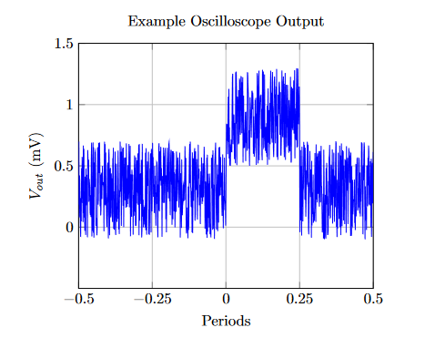

Figure 1: Receiver output where pulsed signal power sits just above the noise floor.

The setup to this experiment is shown in Fig. 2 and as follows. A signal generator is used to create a pulsed input signal at a given frequency and an oscilloscope is used to read the output. Then, a step attenuator is used to tune the output trace to a 2.5:1 ratio of signal-to-noise RMS voltage. In this case, a 1 kHz pulse with a 20% duty cycle was used; the output of each receiver setup when biased with no input signal measured roughly 400 µV, thus, an RMS signal voltage of 1 mV is desired for TSS.

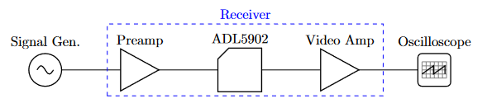

Figure 2: Test setup block diagram.

# Results

The ADL5902 evaluation board was used in each receiver although it has been slightly modified to increase the gain to approximately 86 mV/dB; R6 was replaced with a 1180Ω resistor and R2 was replaced with a 2kΩ resistor. The voltage-power curve in this configuration is shown in Fig. 3. TSS levels were measured across a frequency range of 2-10 GHz at various receiver configurations. All of these are outlined in Fig. 4.

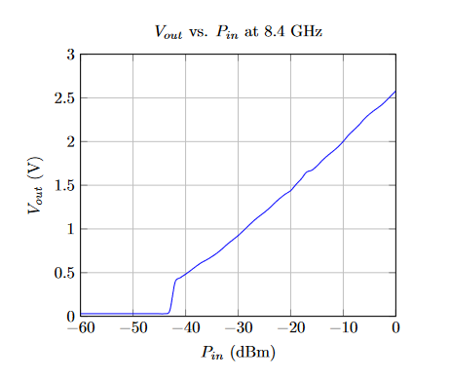

Figure 3: Power sweep of the ADL5902-EVALZ. R6 = 1180Ω and R2 = 2000Ω.